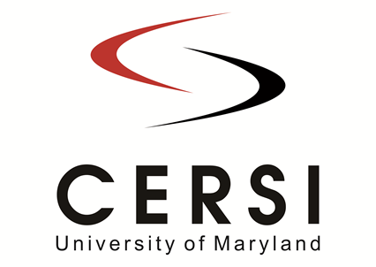

Information Sheet for
University of Maryland Center of Excellence in Regulatory Science and Innovation (M-CERSI)
“America’s Got Regulatory Science Talent” Competition

Team name:
Less-than-12-word description of proposed solution:

Name of team captain:
Email of team captain:
Faculty or FDA advisor (optional):
Anticipate AV needs (e.g., microphones, sound system, PPT):

Names of team members (and their college/school/program affiliation):

Questions? Email: RegSciTalent@rx.umaryland.edu
Due to RegSciTalent@rx.umaryland.edu by Jan 16, 2023. This form is available at www.cersi.umd.edu.

